Name Muhammad Hassan Noor
Roll No: ME-24321 (Section E)
Course: Applied Probability and Statistics (MT-330)

Practical No. 01
PART (A):
Time series Plot of Company A & B
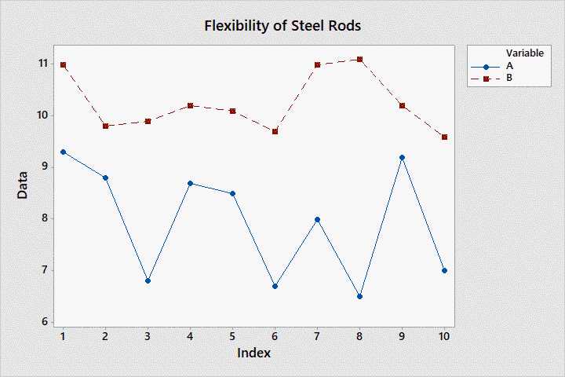
Part (B):
(1)
MTB > LET K1=SUM(C1)*SUM(C2)
MTB > NAME K1 'SUM(C1)*SUM(C2)'
MTB > PRINT K1

Data Display

SUM(C1)*SUM(C2) 8156.70

(2)

MTB > LET K2=SUM(C1*C2)
MTB > NAME K2 'SUM(C1*C2)'
MTB > PRINT K2

Data Display

SUM(C1*C2) 816.630

(3)

MTB > LET K3=SQRT(SUM((5*C1)+C2))
MTB > NAME K3 '=SQRT(SUM((5*C1)+C2))'
MTB > PRINT K3

Data Display

=SQRT(SUM((5*C1)+C2)) 22.3629

(4)

MTB > LET K4=SUM(ABSO((2*C1)-(5*C2)))
MTB > NAME K4 'SUM(ABSO((2*C1)-(5*C2)))'
MTB > PRINT K4

Data Display

SUM(ABSO((2*C1)-(5*C2))) 354.000

(5)

MTB > LET K5=SUM((C1+C2)**3)
MTB > NAME K5 'SUM((C1+C2)**3)'
MTB > PRINT K5

Data Display

SUM((C1+C2)**3) 61241.3

(6)

MTB > LET K6=EXPO(SUM(C1))

* NOTE * Value larger in absolute value than 1.001000E+18 in K6 converted
* to missing.

